GIT HandsOnLAB - 1

In this hands-on lab, you will learn how to:
- Setup your machine with Git Configuration
- Integrate notepad++.exe to Git and make it a default editor
- Add a file to source code repository

Step 1: Setup your machine with Git Configuration

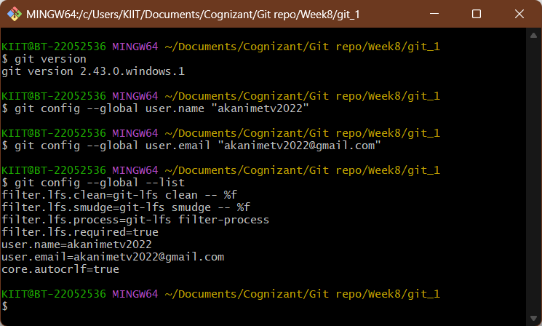

Step 2: Integrate notepad++.exe to Git and make it a default editor

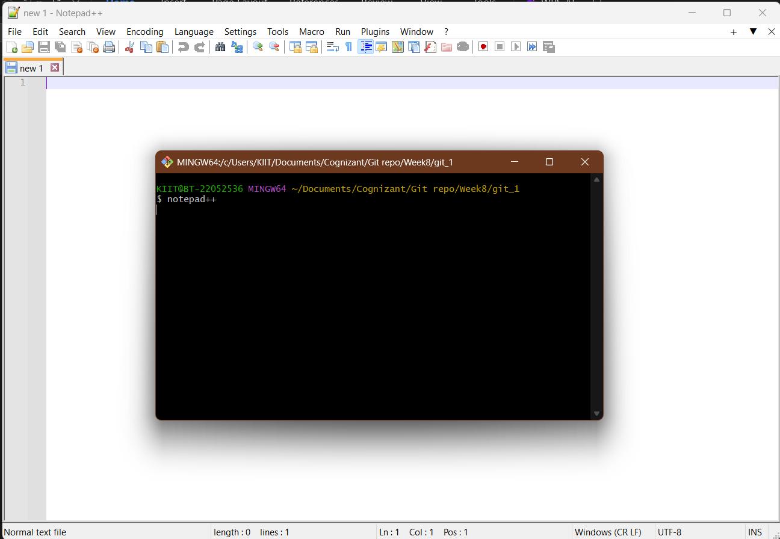
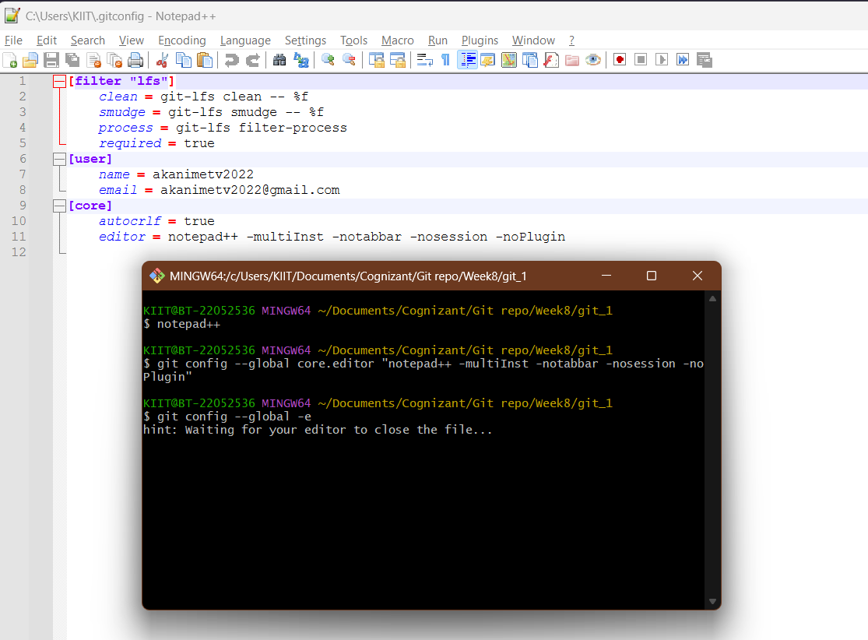

Step 3: Add a file to source code repository

